Problem 1:
- Create table Orders with following columns and appropriate data types.
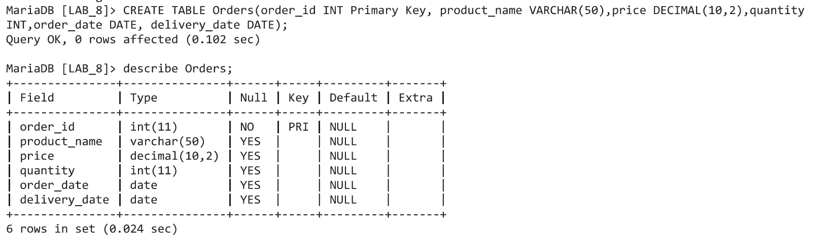
- Insert 8 rows in orders table
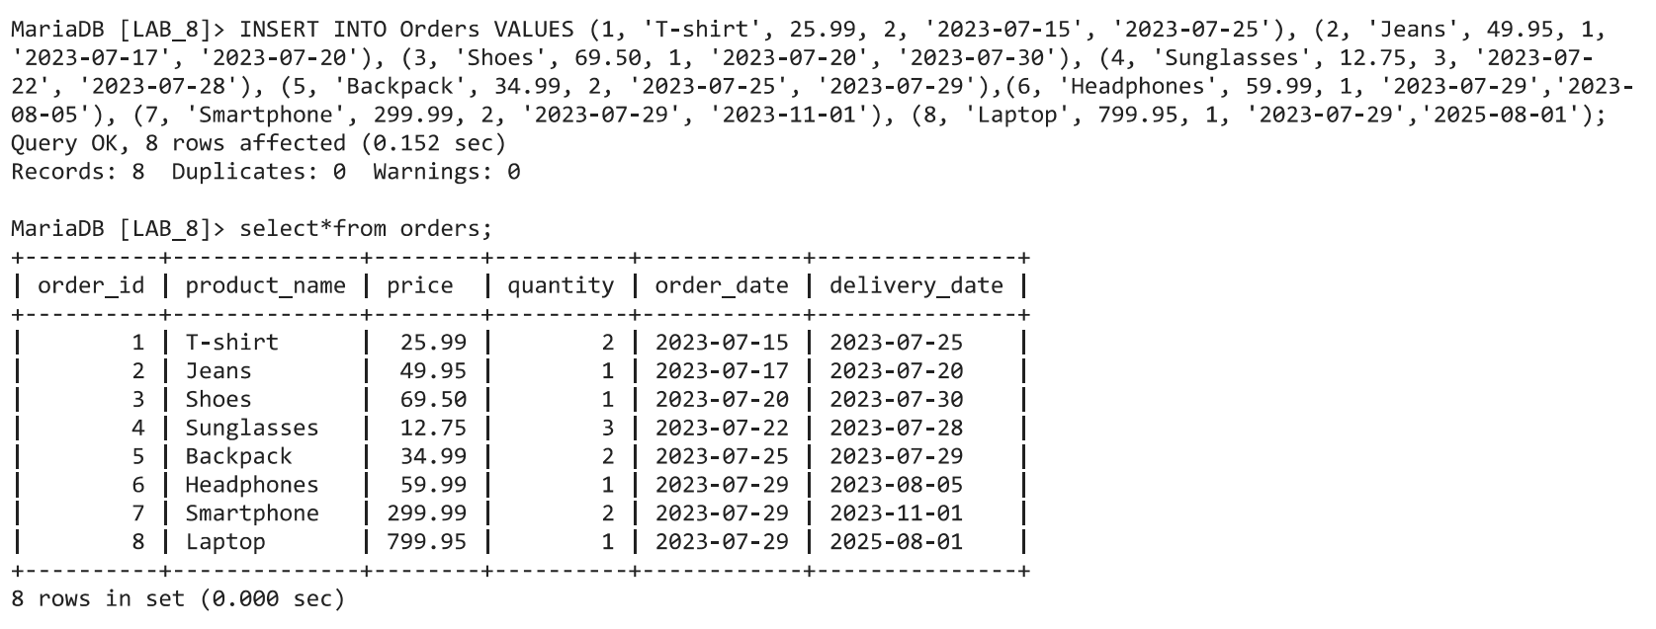
- Retrieve all orders placed on a 2023-07-15
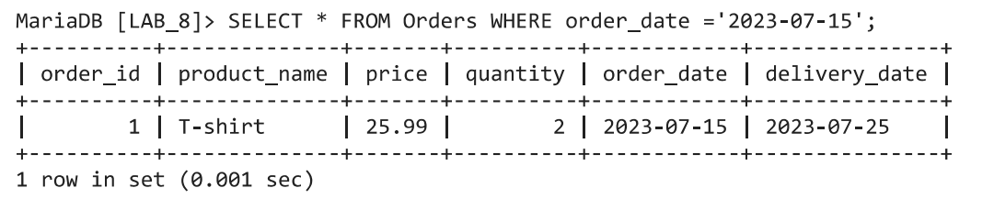
- Find the number of days that required to delivered shoes.
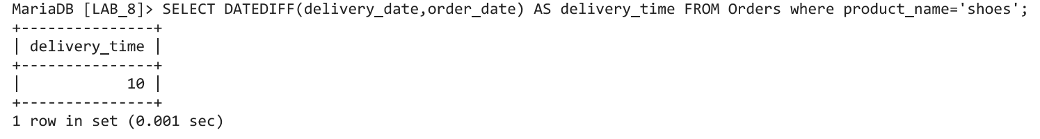

- Find all the orders that is received from '2023-07-15' to '2023-07-25
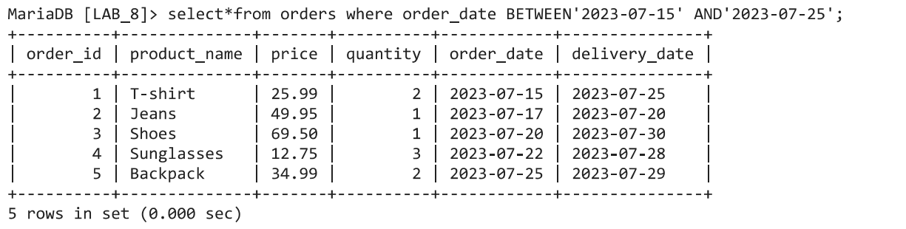
- Find all the orders that is received today
- Calculate the average number of days it takes to deliver a orders.
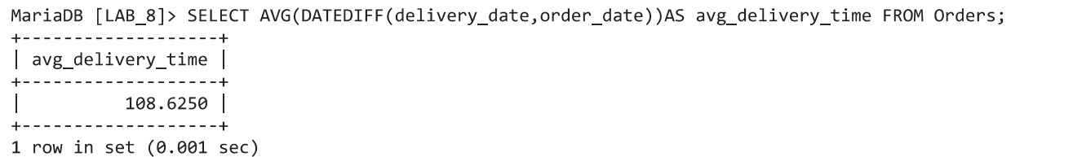
- Find the number of months required to deliver smartphone
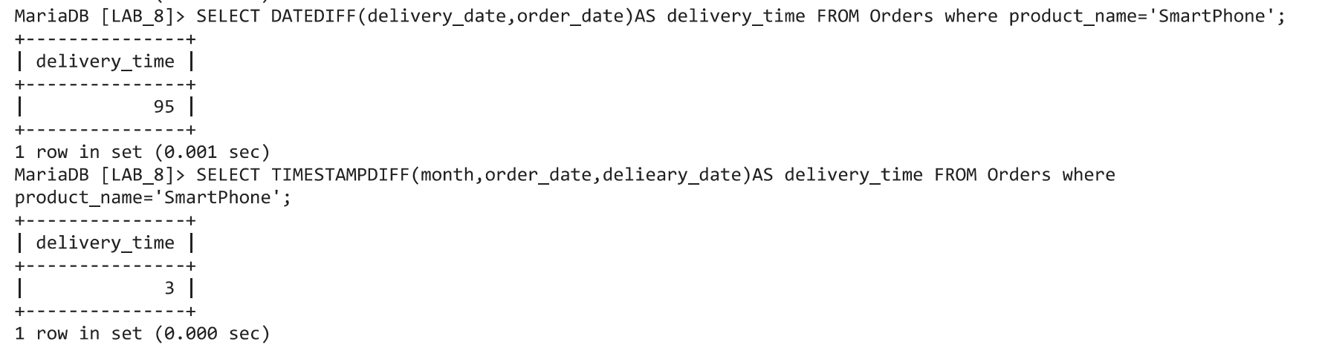
- Find the number of weeks required to deliver smartphone
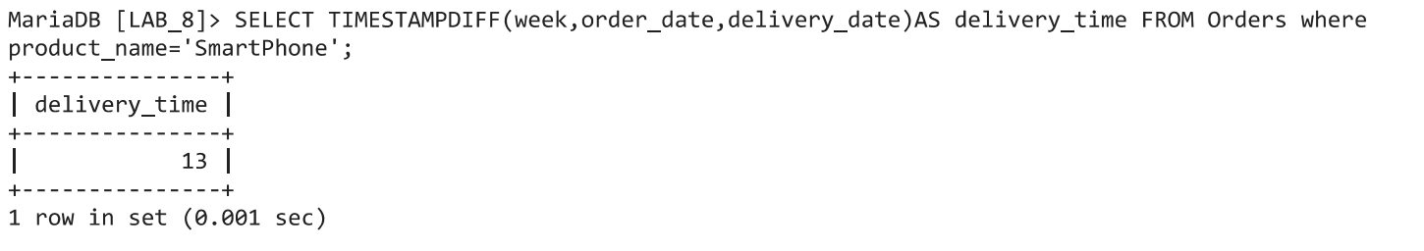
- Find the products that required more than 2 month to delivered
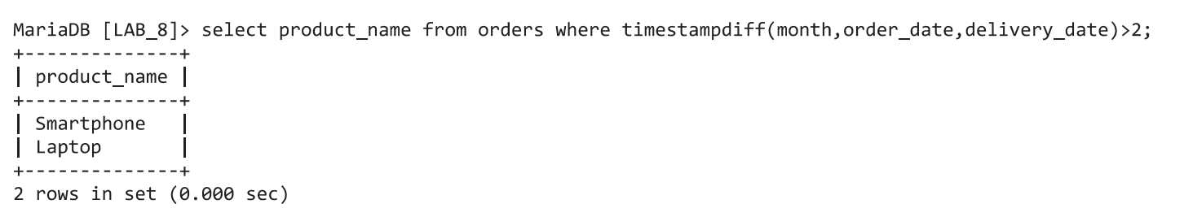
- Find the products that required more than 3 weeks to delivered
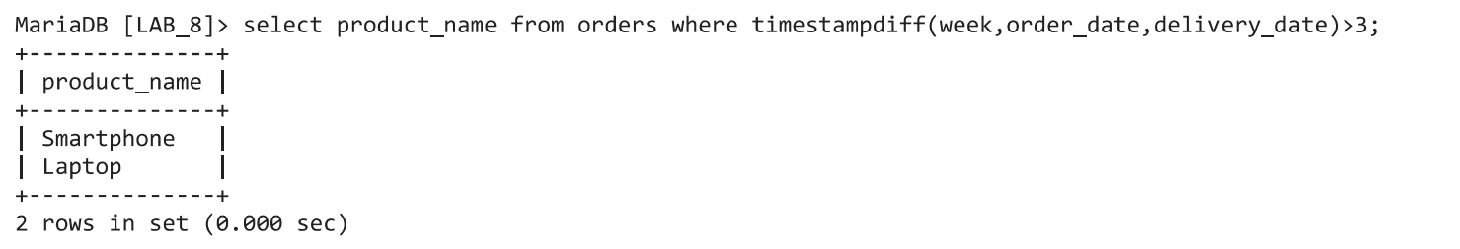
- Find the products that required more than 1 years to delivered.
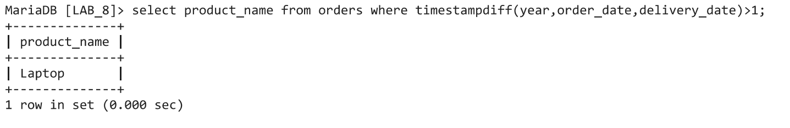

Problem 2:
Write SQL statements for the following queries in reference to relation Emp_time provided.
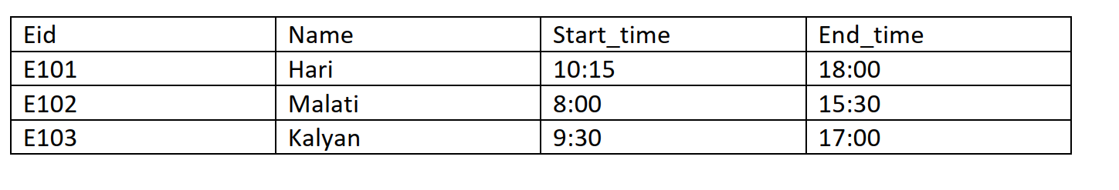
- Create the table Eid as primary key and insert the values provided
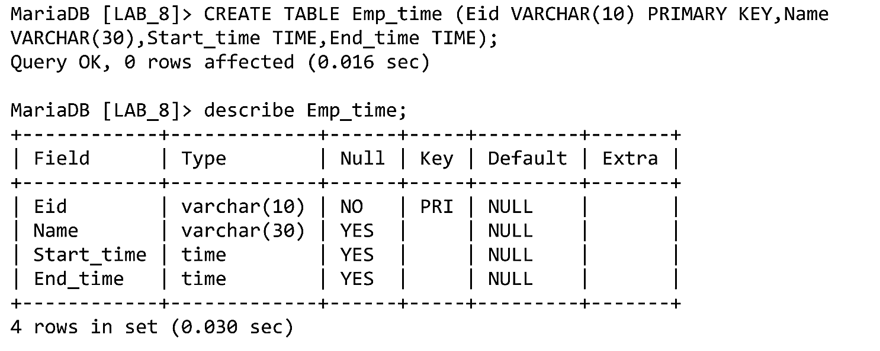
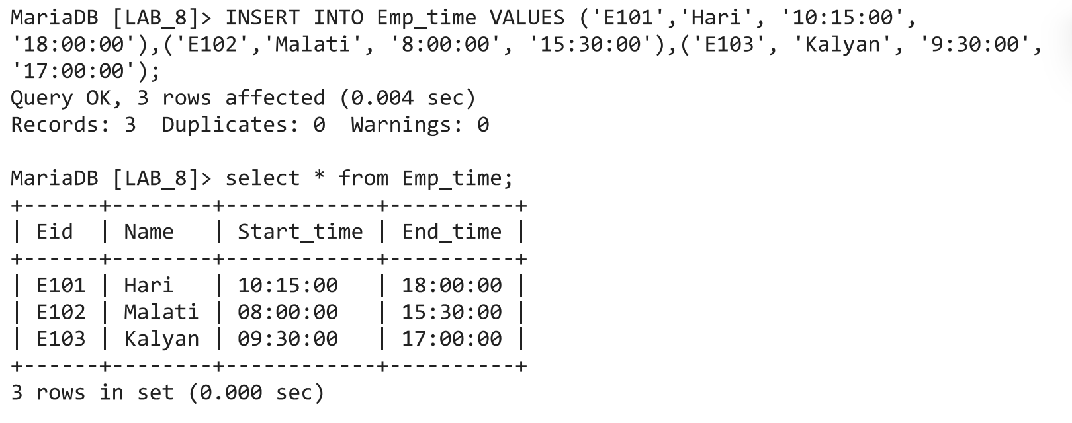
- Select all employees and their total working hours
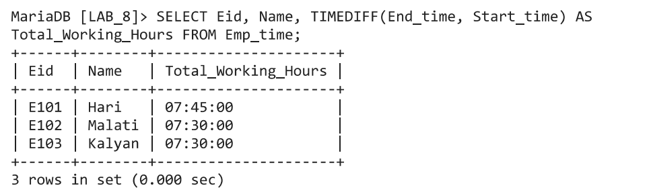
- Find the Employee information as per their least working hours.
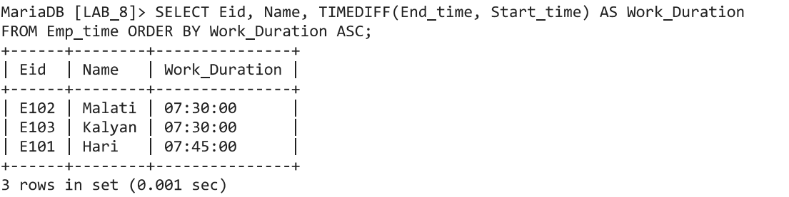
- Find the Employee information as per their long working hours.
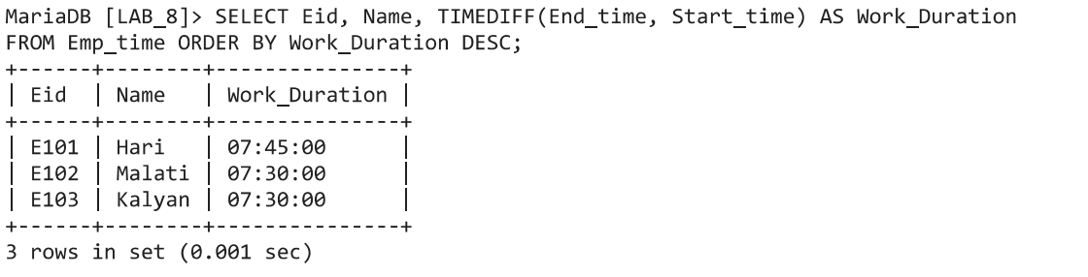
- Select the employee name who works long hours among all the employees.
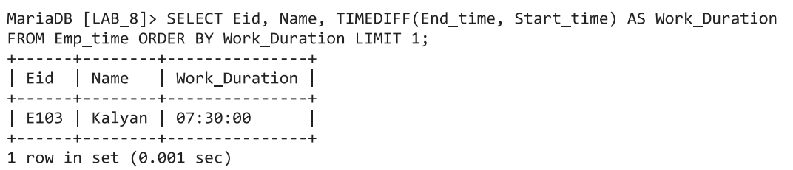
- Find employees who worked more than 7 hours
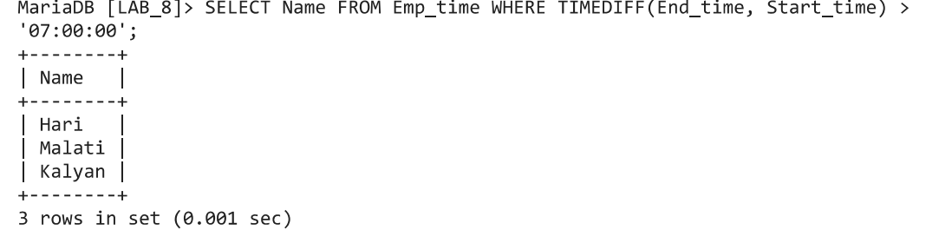
- Display the name of the employee whose name start from letter ‘M’ and who work more than seven hours.
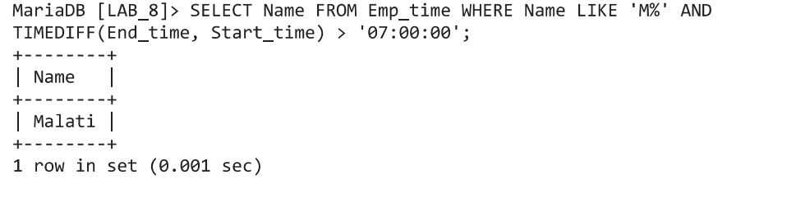
- Delete the entire content of the table so that new records can be inserted.
